

2025 - 2026
PROJECT REPORT ON

RECIPE MANAGEMENT SYSTEM

Submitted to

NMAM INSTITUTE OF TECHNOLOGY, NITTE
(Off-Campus Centre, Nitte Deemed to be University, Nitte - 574 110, Karnataka, India)

In partial fulfilment of the requirements for the award of the Degree of Bachelor of Technology
in

INFORMATION SCIENCE AND ENGINEERING
by

SHRIDHAR V KAMATH NNM23IS176 SRAJAN D PRABHU NNM23IS184

Under the guidance of

Dr. Preethi Salian K
Associate Professor

[ i ]

INTRODUCTION

In today’s digital world, managing information efficiently has become essential. Traditional methods of storing recipes in notebooks or books are time-consuming and difficult to organize. A Recipe Management System provides a simple and effective way to store, manage, and retrieve recipes using a digital platform.
This project focuses on developing a web-based Recipe Management System using MongoDB to perform CRUD (Create, Read, Update, Delete) operations. The system allows users to add new recipes, view existing ones, update details, and delete recipes when required. Each recipe can include information such as name, ingredients, cooking time, and category, making it easier to organize and access data.
MongoDB, a NoSQL database, is used to store recipe data in a flexible and efficient format. It enables faster data handling and allows easy modification of data structure when needed. The backend of the application is developed using Node.js and Express.js, which handle database operations and API requests, while the frontend is built using HTML, CSS, and JavaScript to provide a user-friendly interface.
The system also includes filtering and search features, allowing users to find recipes based on category, cooking time, ingredients, or name. These features improve usability by making data retrieval quick and convenient.
Overall, this project demonstrates how modern web technologies and databases can be used to build a simple and efficient application for managing data in a structured way.

SCREENSHOTS:-

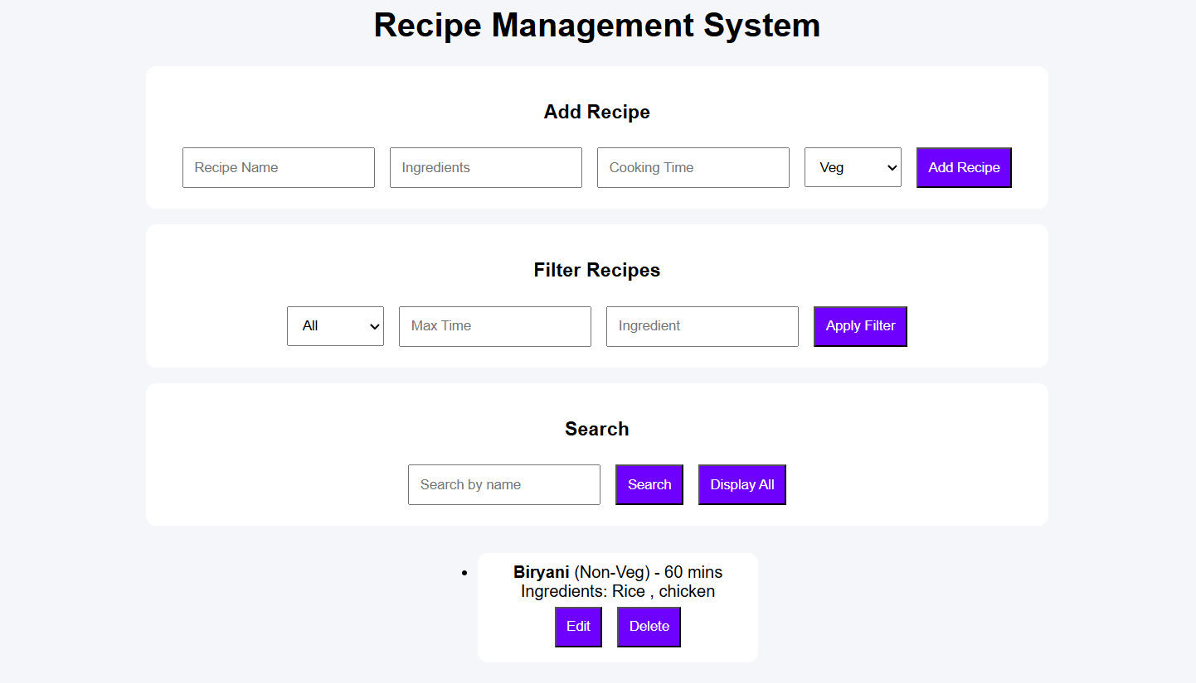
  - Adding recipe

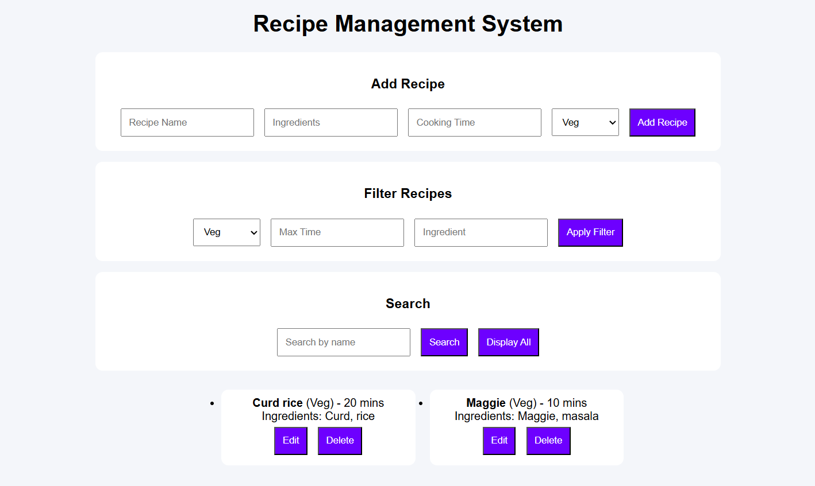
  - Filter recipe

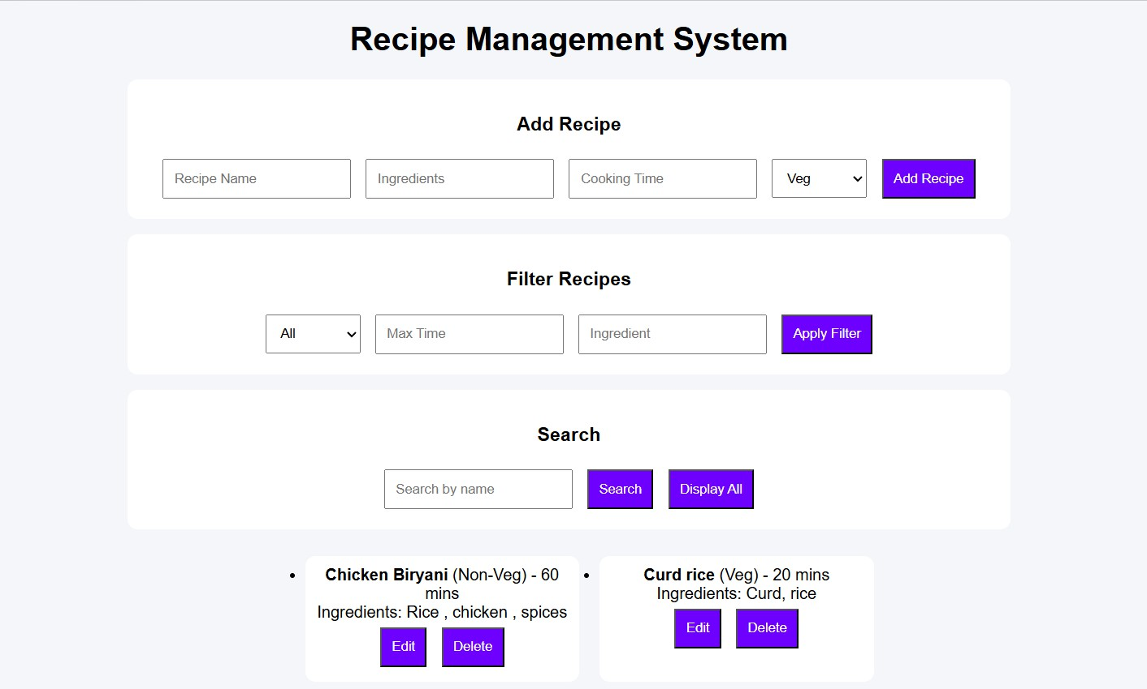
  - Edit recipe

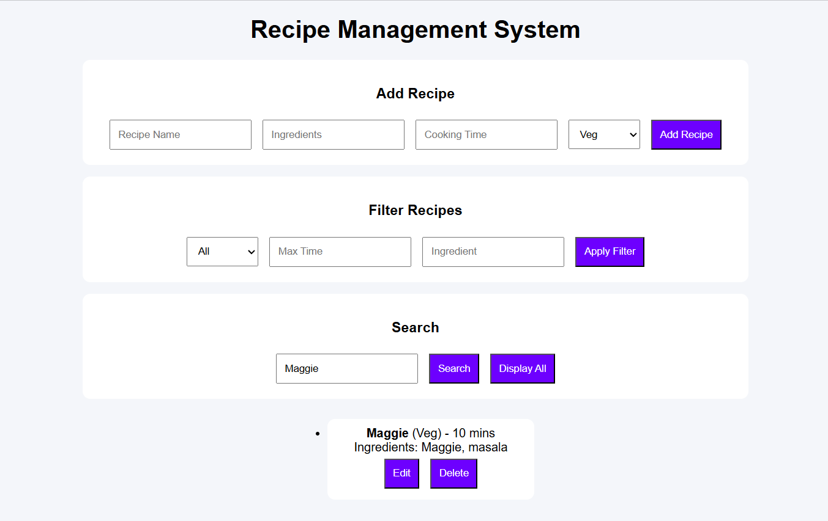
  - Search recipe

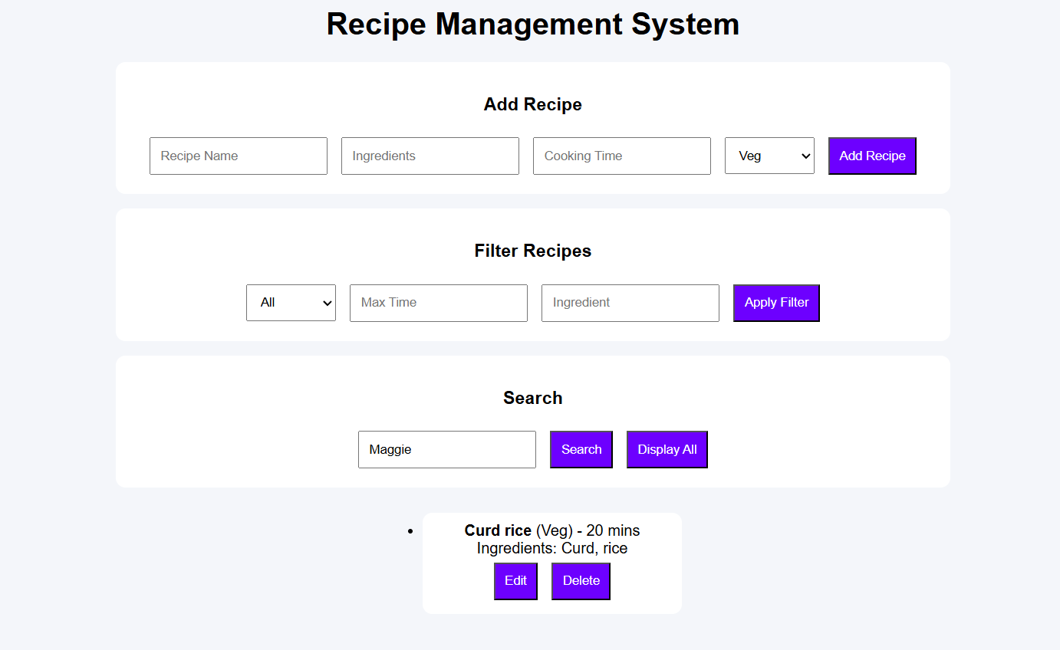
  - Delete recipe

CONCLUSION
The Recipe Management System successfully implements CRUD operations using MongoDB, along with search and filtering features for efficient data management. It provides a simple and user-friendly interface to add, view, update, and delete recipes.
This project demonstrates the integration of frontend and backend technologies, highlighting practical knowledge of database handling and web application development. Overall, it is an effective solution for organizing and managing recipe data efficiently.

